Kingston St Mary C of E Primary School
Relationships, Sex and Health Education Policy
Statement of Intent
At Kingston St Mary C of E Primary School, we understand that pupils must be provided with an education that prepares them for the opportunities, responsibilities and experiences of adult life. A key part of this relates to relationships education, which must be delivered to every primary-aged pupil. Primary schools also have the option to decide whether pupils are taught sex education. State-funded primary schools are also required to teach health education.

Relationships education focusses on giving pupils the knowledge they need to make informed decisions about their wellbeing, health and relationships, and to build their self-efficacy. Health education focusses on equipping pupils with the knowledge they need to make good decisions about their own health and wellbeing.

We understand our responsibility to deliver a high-quality, age-appropriate and evidence-based relationships and health curriculum for all our pupils. This policy sets out the framework for our relationships and health curriculum, providing clarity on how it is informed, organised and delivered.

We understand our responsibility to deliver a high-quality, age-appropriate and evidence-based relationships, sex and health curriculum for all our pupils. This policy sets out the framework for our relationships, sex and health curriculum, providing clarity on how it is informed, organised and delivered.

Legal framework
All primary schools must teach the following SRE aspects of the Science National Curriculum. Parents do not have the right to withdraw their child/children from the teaching of the biological aspects of human growth and reproduction. Parents have the right to withdraw their child/children from the PSHE and the citizenship element of the curriculum that focuses on puberty and sexual relationships, but will be advised to cover these topics themselves at home. Every child is entitled to receive SRE regardless of their ethnicity, gender, religion, age, culture, disability, sexuality, language, special needs, including disadvantaged or looked after children. It is our intention that all children have the opportunity to experience a programme of SRE at a level which is appropriate for their age and physical development, with differentiated provision if required.
This policy has due regard to all relevant legislation and statutory guidance including, but not limited to, the following:
- Section 80A of the Education Act 2002
- Children and Social Work Act 2017
- The Relationships Education, Relationships and Sex Education and Health Education (England) Regulations 2019
- Equality Act 2010
- DfE (2019) ‘Relationships Education, Relationships and Sex Education (RSE) and Health Education’
- DfE (2013) ‘Science programmes of study: key stages 1 and 2’
- DfE (2021) ‘Teaching about relationships, sex and health’

Roles and responsibilities
The governing board is responsible for:
- Ensuring all pupils make progress in achieving the expected educational outcomes.
- Ensuring the curriculum is well led, effectively managed and well planned.
- Evaluating the quality of provision through regular and effective self-evaluation.
- Ensuring teaching is delivered in ways that are accessible to all pupils with SEND.
- Providing clear information for parents on subject content and their rights to request that their children are withdrawn.
- Making sure the subjects are resourced, staffed and timetabled in a way that ensures the school can fulfil its legal obligations.
- Ensuring the religious ethos of the school is maintained and developed through the subjects.

The headteacher is responsible for:
- The overall implementation of this policy.
- Ensuring staff are suitably trained to deliver the subjects.
- Ensuring that parents are fully informed of this policy.
- Reviewing requests from parents to withdraw their children from the subjects.
- Discussing requests for withdrawal with parents.
- Organising alternative education for pupils, where necessary, that is appropriate and purposeful.
- Reporting to the governing board on the effectiveness of this policy.
- Reviewing this policy on an annual basis.
- The relationships, sex and health education subject leader and head teacher is responsible for:
- Overseeing the delivery of the subjects.
- Ensuring the subjects are age-appropriate and high-quality.
- Ensuring teachers(where it is taught by them) are provided with adequate resources to support teaching of the subjects.
- Ensuring the school meets its statutory requirements in relation to the relationships, sex and health curriculum.
- Ensuring the relationships, sex and health curriculum is inclusive and accessible for all pupils.
- Working with other subject leaders to ensure the relationships, sex and health curriculum complements, but does not duplicate, the content covered in the national curriculum.
- Monitoring and evaluating the effectiveness of the subjects and providing reports to the headteacher.

The appropriate teacher is responsible for:
- Delivering a high-quality and age-appropriate relationships, sex and health curriculum in line with statutory requirements.
- Using a variety of teaching methods and resources to provide an engaging curriculum that meets the needs of all pupils.
- Ensuring they do not express personal views or beliefs when delivering the programme.
- Modelling positive attitudes to relationships, sex and health education.
- Responding to any safeguarding concerns in line with the Child Protection and Safeguarding Policy.
- Acting in accordance with planning, monitoring and assessment requirements for the subjects.
- Liaising with the SENCO to identify and respond to individual needs of pupils with SEND.
- Working with the relationships, sex and health education subject leader to evaluate the quality of provision.

Organisation of the curriculum
Every primary school is required to deliver statutory relationships education and health education. At Kingston St Mary C of E Primary School, Relationships Education and of Health Education will be delivered as part of the school’s PSHE, Science and Computing curriculums.
For the purpose of this policy:
“Relationships and sex education” is defined as teaching pupils about healthy, respectful relationships, focussing on family and friendships, in all contexts, including online, as well as developing an understanding of human sexuality.
“Health education” is defined as teaching pupils about physical health and mental wellbeing, focussing on recognising the link between the two and being able to make healthy lifestyle choices.

Our Relationships and Health curriculum has been organised in line with the statutory requirements outlined in the DfE (2019) ‘Relationships, Education, Relationships and Sex Education (RSE) and Health Education’ guidance.

The Relationships and Health curriculum takes into account the views of teachers, pupils and parents. The school has organised a curriculum that is appropriate for the age and developmental stages of pupils within each year group.

When organising the curriculum, the religious backgrounds of all pupils will be considered, so that the topics that are covered are taught appropriately.

Managing Difficult Questions
Primary-age pupils will often ask their teachers or other adults questions pertaining to sex or sexuality that go beyond what is set out for Relationships Education. Ground rules are essential to provide an agreed structure to answering sensitive or difficult questions. Teachers will establish clear parameters about appropriate and inappropriate questions in a whole-class situation. This framework facilitates the use of an anonymous question box as a distancing technique. Teachers will endeavour to answer questions as honestly as possible but if a teacher is asked a question that they deem inappropriate for the age of the class, they will read the question but explain to the pupils the reason for not answering it.

Consultation with parents
The school informs parents when aspects of the sex and relationship programme are taught and provides opportunities for parents to view any videos and resources being used. Parents have the right to withdraw their children from those aspects of sex and relationship education, not included in the Science National Curriculum. In these cases, children are set alternative work to complete during these sessions. If a parent decides to withdraw their child from this aspect of the curriculum, they must write to the Headteacher. However, this rarely happens, as by working in partnership with parents, they recognise the importance of this aspect of their child’s education.

Child Protection / Confidentiality
Teachers need to be aware that effective sex and relationship education, which brings an understanding of what is and is not acceptable in a relationship, may lead to disclosure of a child protection issue. The staff member will inform the Headteacher /Designated Child Protection Lead person in line with the LA procedures for child protection. A member of staff cannot promise confidentiality if concerns exist.

Curriculum Content
Our coverage of the curriculum is mapped out for each year group; it is devised from the PSHE Association’s coverage overview and the SRE statutory curriculum. Coverage for each year group will be available on the school website.
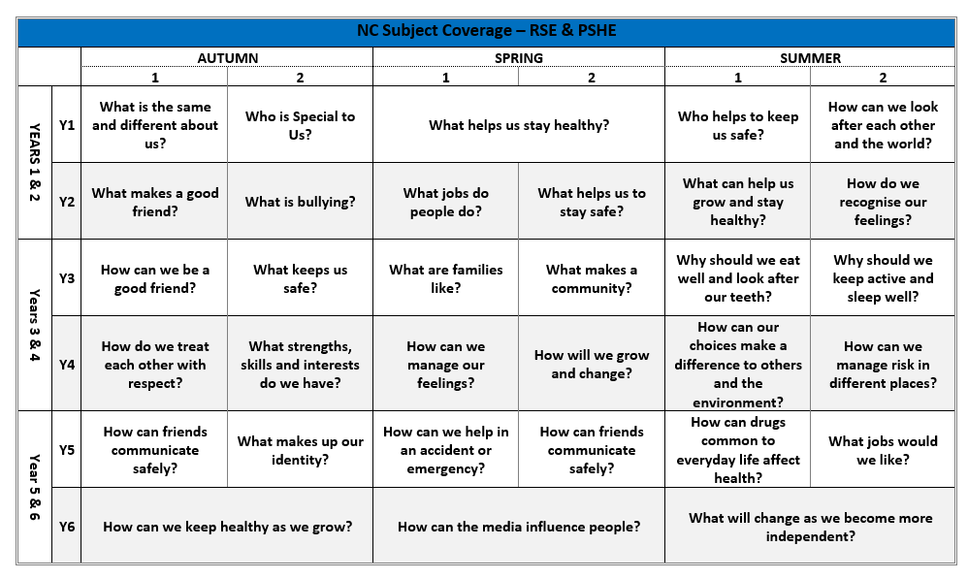

Monitoring and Evaluation
Monitoring is the responsibility of the Headteacher, named governor and teachers with responsibility for sex and relationship education.

The effectiveness of the SRE programme will be evaluated by assessing children’s learning, carrying out anonymous audits and implementing change if required.

This policy document is placed on the school website following approval by the full governing body.

December 2025

