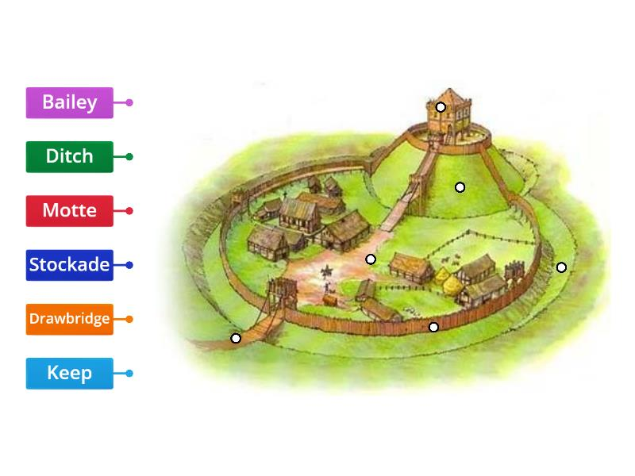
Monday 4th January 2021
Match labels to parts of a Motte and Bailey Castle
It was safe because _______________________________________
The problem with it was ____________________________________ ___________________________________________________________________________________

