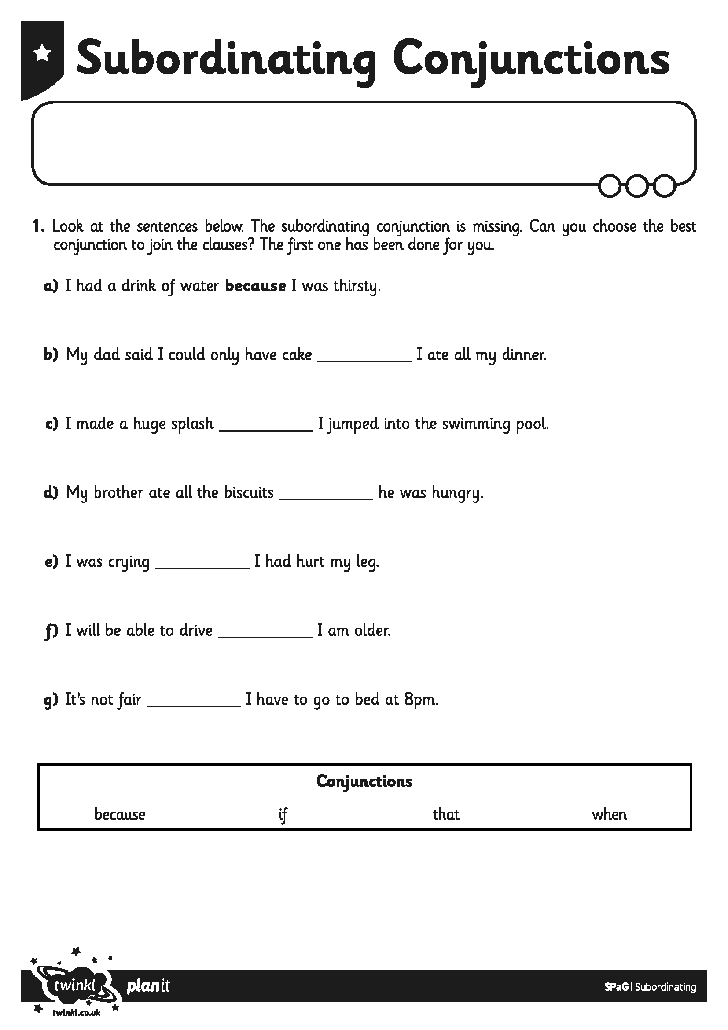
I can use a subordinating conjunction to add information to my sentences.
I can choose the best conjunction for my sentence.
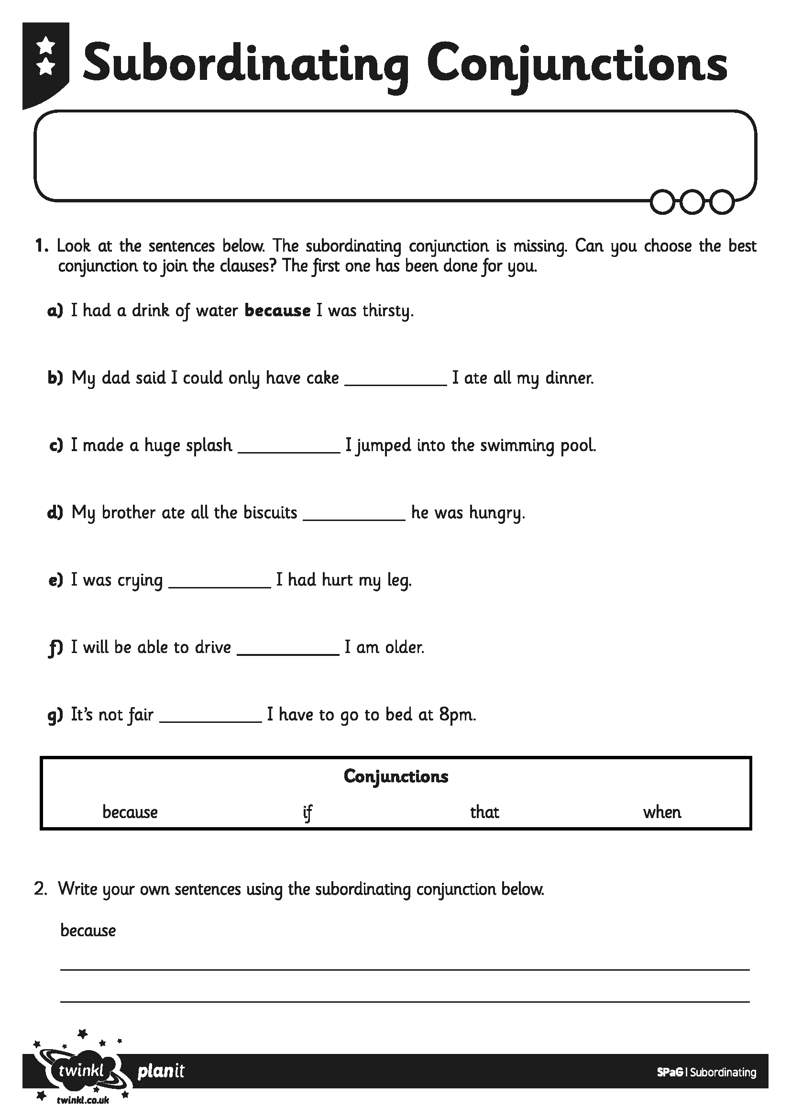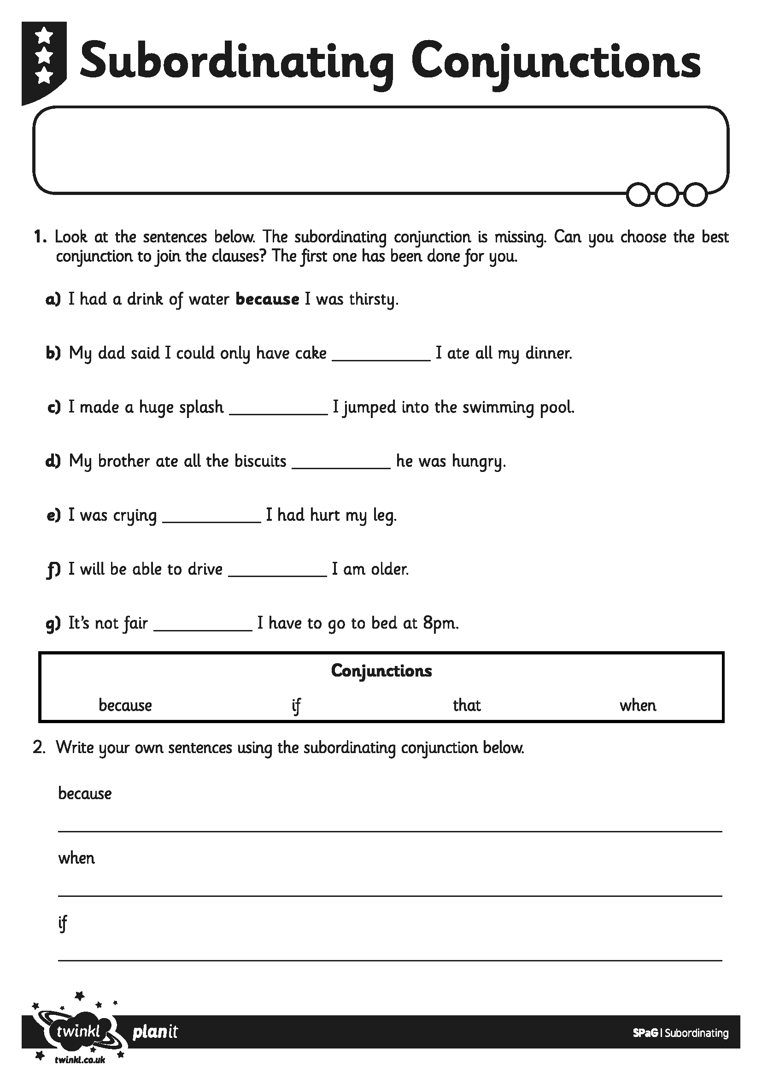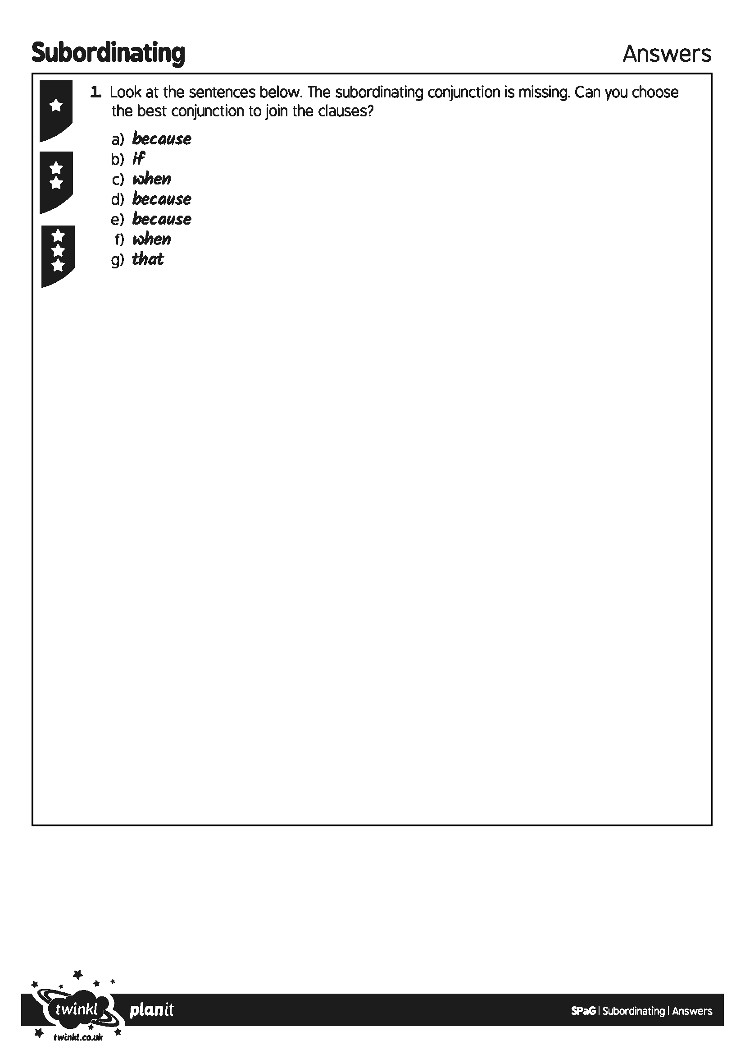
I can use a subordinating conjunction to add information to my sentences.
I can choose the best conjunction for my sentence.
I can use a subordinating conjunction to add information to my sentences.
I can choose the best conjunction for my sentence.

