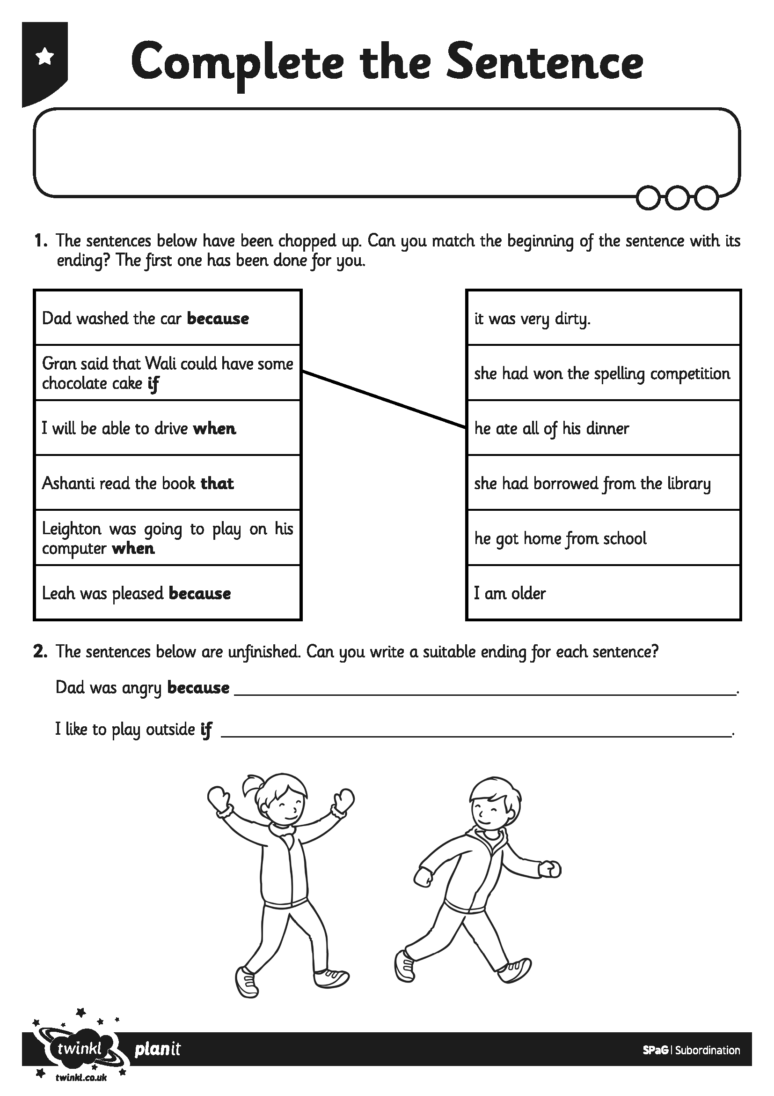
I can use a subordinating conjunction to add information to my sentences.
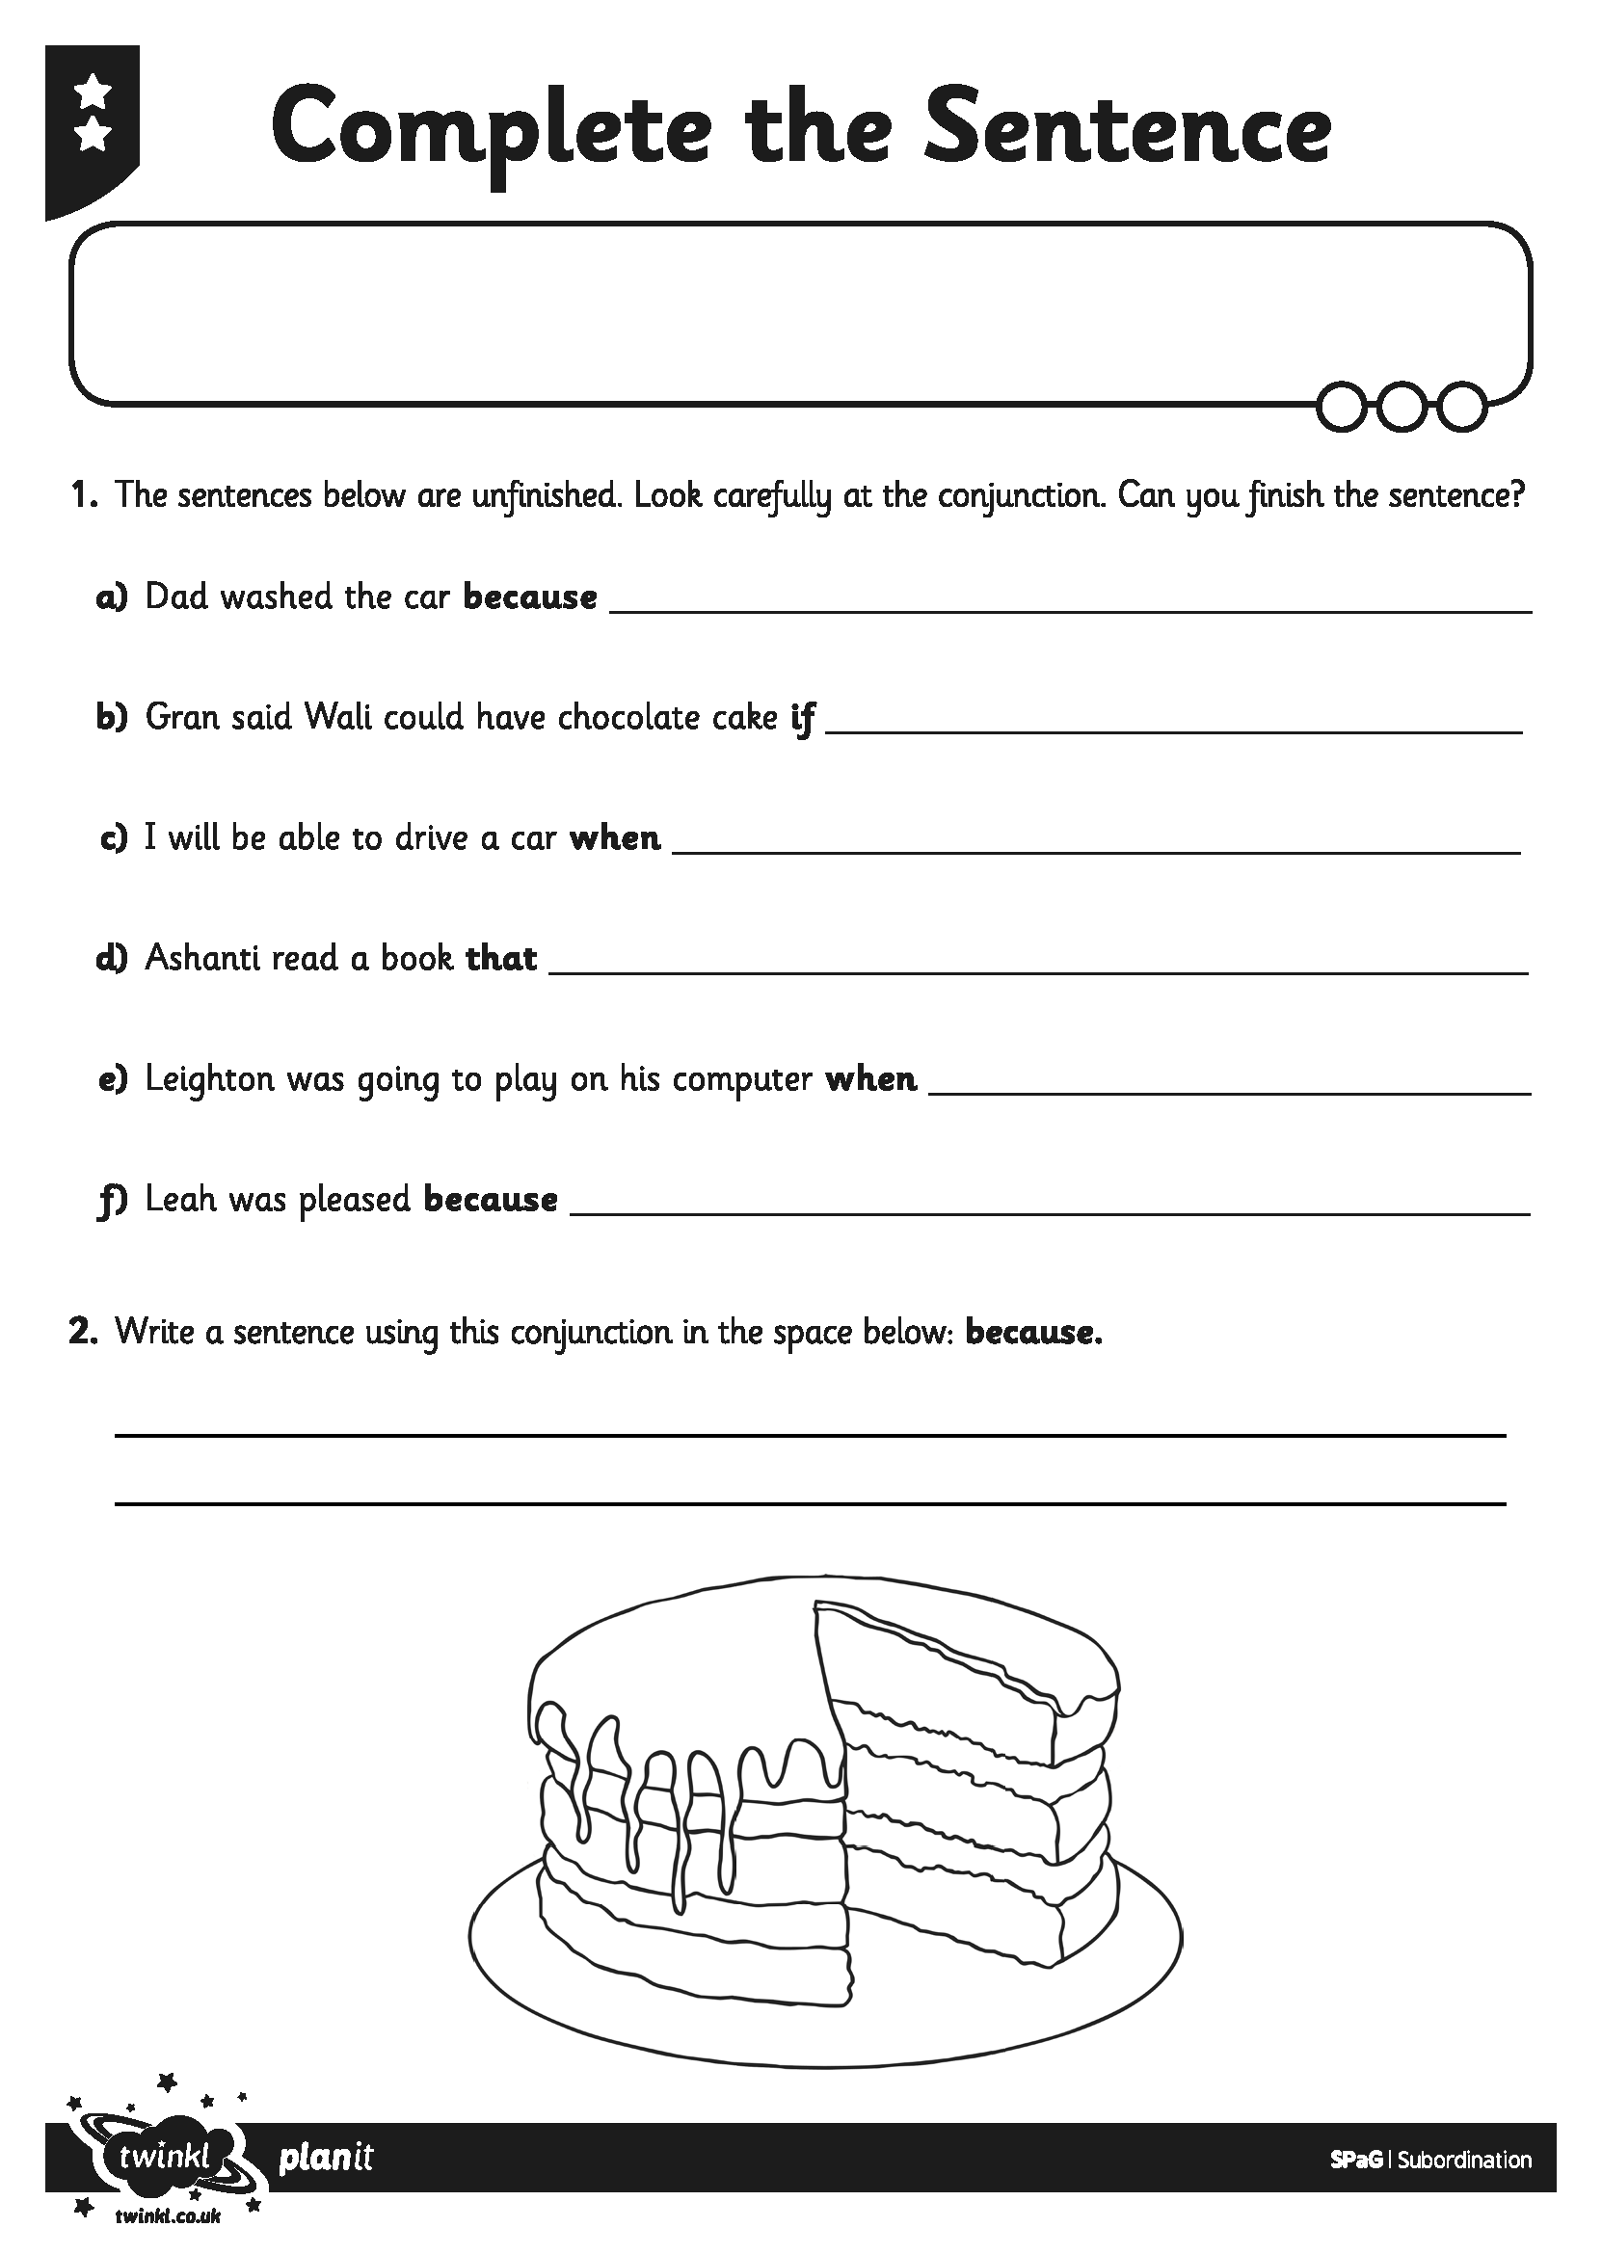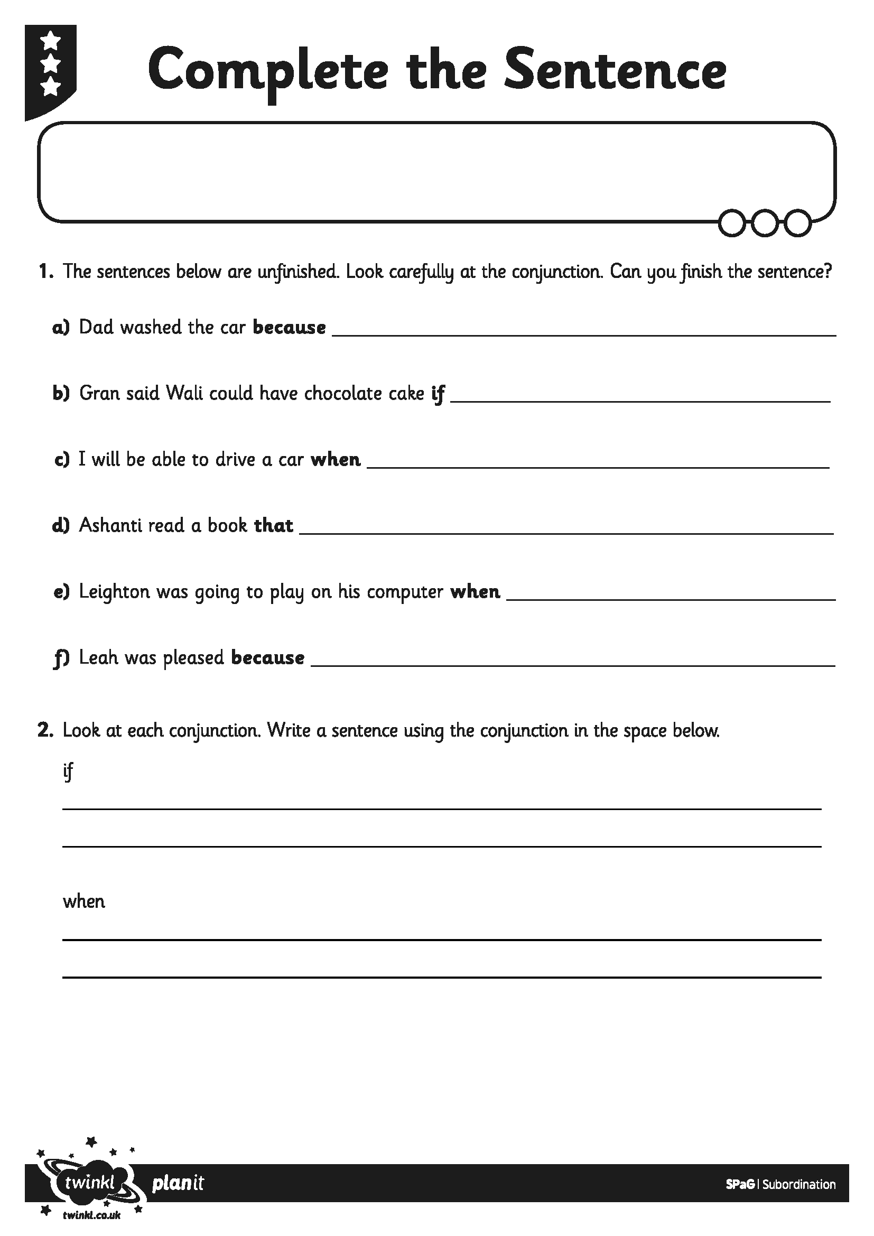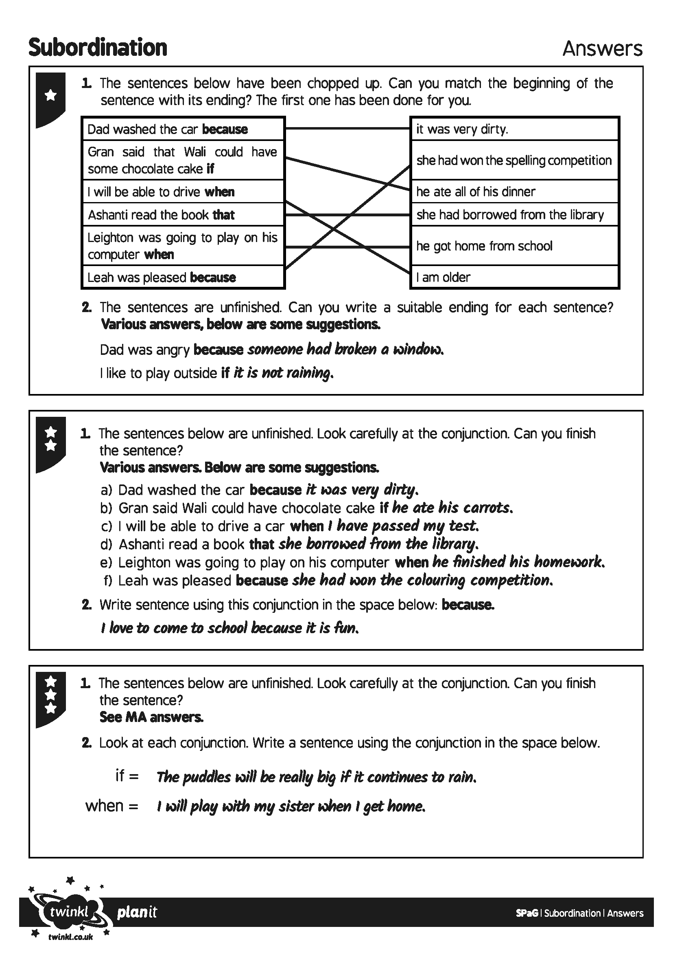
I can use a subordinating conjunction to add information to my sentences.
I can use a subordinating conjunction to add information to my sentences.

