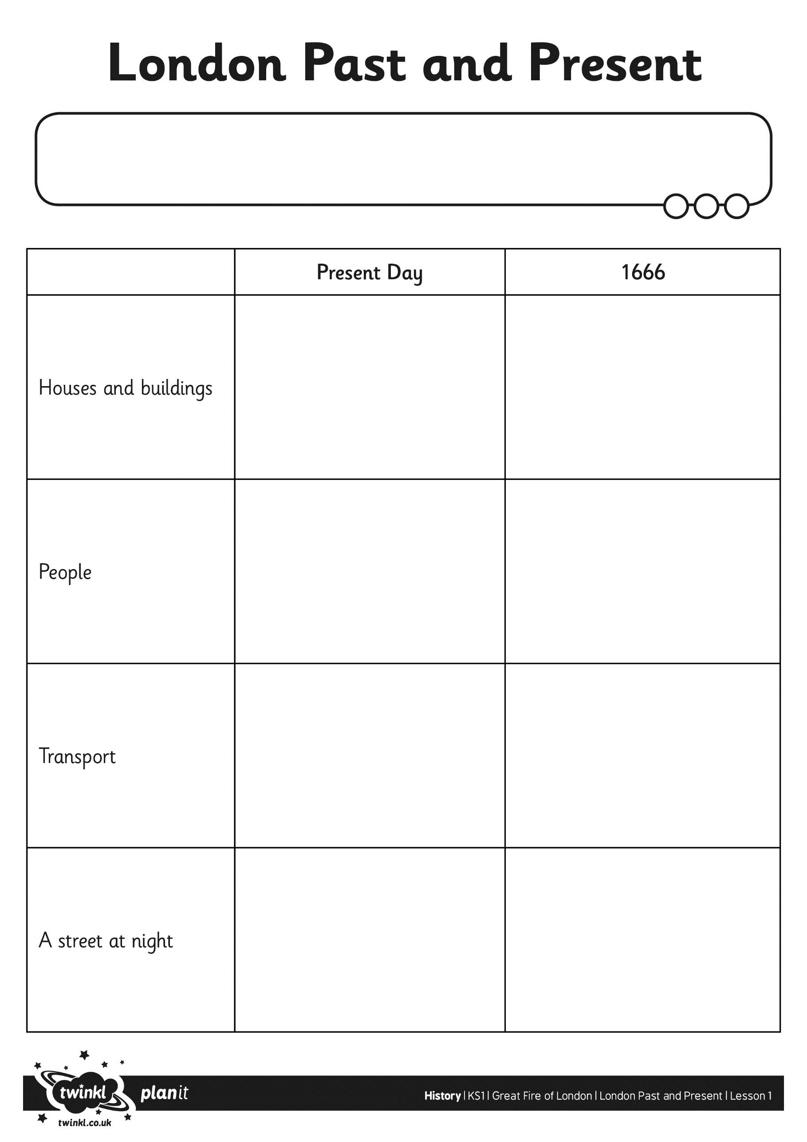
I can find out some of the ways in which London has changed.

