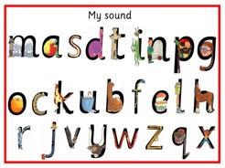

**Kingston St Mary Church of England Primary School**

0

**What do people mean when they talk about ‘phonics’?**

Words are made up from small units of sound called phonemes. Phonic lessons teach children to be able to listen carefully and identify the phonemes that make up each word. This helps children to learn to read words and to spell words independently.

**First Steps: **

We have already begun our first steps towards teaching your child to read. This begins with activities like recognising their names and listening to and making different sounds.

We have also started to teach letter sounds. We follow the “Read Write Inc” scheme of work which recommends the following order:

* m a s d t i n p g o c
* k u b f e l h sh r j v y
* w th z ch q x ng nk

We will adapt the pace in which we cover these phonemes to suit the individual needs of the children.

**Helping at home: **

To begin with you can help your child at home by:

* sharing stories at home
* visiting the library
* encouraging your children to listen to a story and then retell it in their own words
* discussing the pictures in books
* joining in with nursery rhymes
* playing I-spy
* recognising and sounding out the letters from their name
* pointing out words that are important to them

( e.g. showing them the word Mum in a sentence.)

**What should you do with the first reading book?**

* look at the front cover and talk about what it might be about
* point to the words as you read the title
* ask: Can you spot any of the letters from your name?
* look at the pictures and talk about what is happening
* encourage story book language e.g. Once upon a time
* encourage your child to add detail e.g. rather than: It’s a dog. Try: One sunny day the dog was walking over the bridge.

.

**First Reading Books**

The first books your child brings home contain no words. These books can seem a little strange, but they are a valuable first step to being able to read. They help with:

* knowing how to handle books correctly
* introducing characters
* talking about pictures
* developing levels of concentration

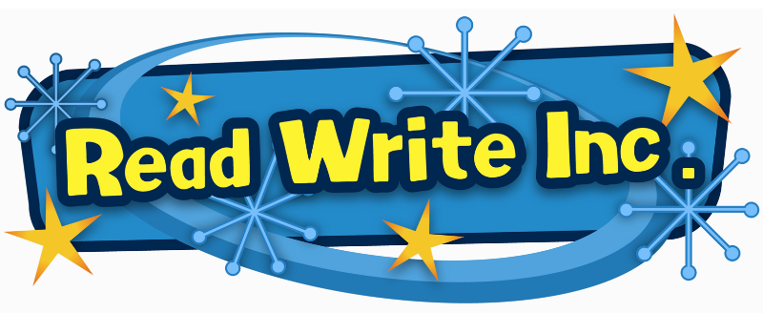

**Reading record:**

Alongside the reading book you will also get a reading record. Please use this to record each time you read with your child including the date and a little comment about what you did together. You can look at the same book **several times** in different ways.

For example:

The first time you could just read the title and look at the pictures together.

Next time you could make up a story to go with the pictures while your child listens.

The following day encourage your child to make up their own story to go with the pictures.

Another day you could play I-spy using the pictures in the book.

Also you could ask your child to find things that make sounds in the pictures e.g. What goes beep/buzz/bang?

Once your child is really familiar with the book encourage them to start adding more detail and story book language into their made-up stories.

We will aim to read individually with your child once a week at school, but this is not always possible. Please bear in mind that this does not mean that they are not reading at school as we also do daily phonics sessions and daily shared reading activities.

If you feel your child is ready for a new book and you have looked at the book together several times in a variety of ways please let us know and we will exchange it for a different one.

Books are Brilliant!

Let’s unlock a love of reading.

**Pure Phonemes and Blending**

When teaching the letter sounds it is important that we say the sound without adding an ‘uh’ sound at the end as will hinder blending later on.

For example ‘s’ is pronounced like a snake saying ssssss not ‘suh’

The Jolly Phonics App is very helpful in allowing you to hear these phonemes voiced correctly.

Blending is when the letters are said together to read the word e.g. c -a -t are all put together to make the word “cat”.

When you are reading to your child you can say these short simple words in sound talk and get your child to blend them for you.

E.g. “And they all went to b-e-d.”

Meet the characters.

