Kingston St Mary Primary School
Mrs Griffiths - EYFS Curriculum Newsletter
January 2024
Curriculum Information - Topics
Autumn 1 | Autumn 2 | Spring 1 | Spring 2 | Summer 1 | Summer 2
Marvellous Me | Let’s Celebrate | People Who Help Us | New Life | Amazing Animals | It’s a Wonderful World

Reception Curriculum
Curriculum Area | EYFS | Home Enrichment Activities
Personal, Social and Emotional Development | Continue to reinforce expected behaviour in the home setting. Praise positive choices and discuss the consequences of inappropriate behaviour and actions. Play games together that involve turn taking and model how to wait patiently. Encourage your child to talk about upcoming events and celebrations. Pay attention to the way they communicate, prompting them to speak in full sentences. Encourage your child to get dressed and undressed independently, practising those things that they find tricky. Get your child to practise putting on their own coat and doing up the zip.
Physical Development | Children will continue to use the outdoor classroom and access the Trim Trail. Here, they will work on developing their strength, balance and coordination. PE will be included in outdoor activities as well as accessing the hall for sessions. Children will engage in a range of ring games and parachute games, developing team building skills and cooperation. We will be working on developing fine motor skills in the classroom to support children’s writing. Activities such as playdough, threading and cutting will be available daily. | Take your child on a walk to practise their gross motor skills (stomping, skipping, running or walking). Encourage your child to get dressed and undressed independently, practising those things that they find tricky. Get your child to practise putting on their own coat and doing up the zip. Encourage your child to practise the letters we have looked at so far (m a s d t I n p g o c k u b f e l h sh r j v y w x ng nk) using a mark making tool. This could be chalks, pens and pencils or their fingers.  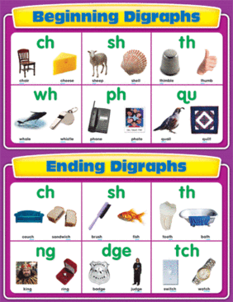
Expressive Arts and Design | During child-initiated learning pupils will have access to a wide variety of creative materials and will be able to express their own creativity. Pupils will be able to access a variety of small world and role play activities to develop expressive language.  Children will also make a toy car using dowels and wheels. They will design, make, test and evaluate it in groups.  Pupils will develop their repertoire of Nursery Rhymes, Action Songs and themed songs. The Nursery rhymes covered this half term are:  - Doctor Foster.  - London Bridge is Falling Down.  - Old Mother Hubbard.  - Polly Put the Kettle On.  - It’s Raining. It’s pouring. | Use playdough to practise rolling, shaping and moulding their own creations.  Listen and sing along at home to the nursery rhymes we have looked at in class.  Nursery Rhymes and Songs – BBC TEACH  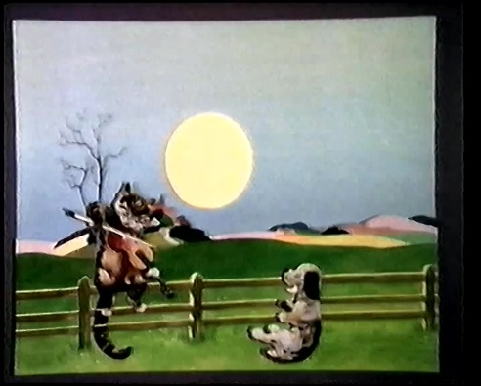
Communication and Language | Children will continue to take part in circle time activities within small groups and whole class. There will be lots of opportunities for pupils to express their views, share stories and become confident to speak in a familiar group. Pupils will have the opportunity to engage in role play to develop their expressive language. | Please read with your child regularly and return books to school so that a new title can be issued. Your child will not receive a new book until their current one is returned. Encourage your child to recognise any ‘tricky words’ they find in their books or their environment. Tricky words are words that cannot always be worked out by blending. In school, pupils will be introduced to all Phase 2 tricky words and are beginning Phase 3 this half term.  Phase 3 Pure Sound Video:  https://www.youtube.com/?v=DvOuc7cWXxc  Phase 3 Tricky Word Song:  https://www.youtube.com/watch?v=R087lYrRpgY
Literacy | Stories covered this half term will include:  - The Smartest Giant in Town.  - The Three Little Pigs.  - The Snowy Day by Ezra Jack Keats.  - My Hair by Hannah Lee & Allen Fatimaharan.  - The Hundred Decker Bus by Mike Smith.  - I Love Chinese New Year by Eva Wong Nava.  Songs covered will include:  - Seasons Song.  - Here Comes the Fire truck.  - Chinese New Year Dragon Dance.  - Subitise Rock to 10.  Pupils will continue to develop their writing skills:  - Letter formation.  - Writing on the line.  - Full name writing.  - Words and sentences containing the learned phonic sounds.  Nursery Rhymes:  - 5 Speckled Frogs.  - 5 Current Buns.  - 5 Little Ducks.  - 5 Little Men in a Flying Saucer.  - 5 Little Monkeys. | Listen to your child read their reading book, developing confidence and fluency in their reading. Record the tricky words on paper and display them around your house. Can your child find and read all of the words? Encourage your child to identify letters in the environment, e.g. number plates, signs, magazines etc. Encourage your child to read any words they can blend if they see when out and about e.g. in the supermarket. Read a story to your child every day. Encourage your child to talk about the illustrations in the stories. Model how to hold a book correctly and turn pages. Feed your child’s imagination and deepen their vocabulary by telling them a range of stories. Encourage your child to mark make at any opportunity (bath chalks, water and paint brushes, shaving foam). Ensure practise writing their first name and surname if they can extend this to words they can read, can they record them too? Can they write about a picture they have drawn?  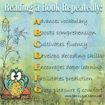
Mathematics | During maths, this half term, we will begin by looking at the composition of the number five and recap previous learning. From this we will move on at measuring capacity, comparing length and comparing height.  We will then grow our numbers further by looking at 6, 7 and 8. Alongside this, we will look at one more and one less. We will also look at doubling numbers to 8 and explore odd and even numbers. | Compare the weight of everyday objects at home. Which is the lightest? Which is the heaviest? Can you find an object heavier than….?  Capacity – Water play with different containers. Which container holds the most/least? Encourage the use of the vocabulary, full, half full and empty.  Number activities: Practise adding two groups of objects together to find the total. Encourage and model accurate counting to enable precision.
Understanding the World | This half term, the topic is ‘People Who Help Us’.  Children will learn about people in the community who help us:  - Firefighters.  - Doctors.  - Police.  - Vets.  - Teachers.  Children will be introduced to different jobs such as farmer, hairdressers and retail workers. Children will be encouraged to compare photographs of people who help us now compared to 100 years ago. The children will be encouraged to discuss the differences from then and now.  They will find out about where and how these are celebrated around the world.  The children will also explore the season of Winter and look at the changes in the environment. | Discuss with your child at home about people in the local community and how they help us. Go for a walk in the local area and point out where the fire station, doctors and police stations are.  Children can research the job they would like to do when they are older. What skills do they need to learn and develop to do that job?  When going on a walk watch out for the signs of Winter. Talk about the cold weather, it’s getting dark earlier, animals hibernating and the bare branches on the trees.  
Wish List
We are desperate for:
Card
Pritt Sticks
Felt Tip Pens
Playdough
Dressing-Up Outfits for ‘People who Help Us’
Dry Wipe Pens

