Kingston St Mary Primary School
Mrs Griffiths - EYFS Curriculum Newsletter
April 2025
Curriculum Information - Topics
Autumn 1 | Autumn 2 | Spring 1 | Spring 2 | Summer 1 | Summer 2
Marvellous Me | Let’s Celebrate | People Who Help Us | New Life | Amazing Animals | It’s a Wonderful World

Reception Curriculum
Curriculum Area | EYFS | Home Enrichment Activities
Personal, Social and Emotional Development | Children will be encouraged to take part in circle time activities within small groups and whole class. There will be lots of opportunities for pupils to express their views, share stories and become more confident to speak in a familiar group. | Please read with your child regularly and return books to school so that a new title can be issued. Your child will not receive a new book until their current one is returned. Encourage your child to recognise any ‘tricky words’ they find in their books or their environment. Tricky words are words that cannot always be worked out by blending. In school, pupils will be introduced to all Phase 2 tricky words and are beginning Phase 3 this half term.  Phase 3 Pure Sound Video:  https://www.youtube.com/?v=DvOuc7cWXxc  Phase 3 Tricky Word Song:  https://www.youtube.com/watch?v=R087lYrRpgY
Physical Development | Children will continue to use the outdoor classroom and access the Trim Trail. Here, they will work on developing their strength, balance and coordination. PE will be included in outdoor activities as well as accessing the hall for sessions. Children will engage in a range of ring games and parachute games, developing team building skills and cooperation. We will be working on developing fine motor skills in the classroom to support children’s writing. Activities such as playdough, threading and cutting will be available daily. | Take your child on a walk to practise their gross motor skills (stomping, skipping, running or walking). Encourage your child to get dressed and undressed independently, practising those things that they find tricky. Get your child to practise putting on their own coat and doing up the zip.  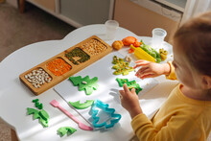
Expressive Arts and Design | Pupils will learn to sing a range of well-known nursery rhyme action songs and themed songs. They will perform songs, rhymes, poems and stories with others, and try to move in time with music.  - Cobbler, Cobbler.  - Tommy Tucker.  - See Saw Margery Daw.  - Ten Green Bottles. | Use playdough to practise rolling, shaping and moulding their own creations.  Listen and sing along at home to the nursery rhymes we have looked at in class.  Nursery Rhymes and Songs – BBC TEACH
Literacy | Pupils will have the opportunity to engage in role play to develop their expressive language. They will use role play scenarios to develop past, present, and future forms in their speech regarding stages of the story.  Stories covered will include:  - Whose egg?  - Daisy and the Beastie.  - Farmer Duck.  - Monkey Puzzle.  - Rumble in the Jungle.  - The Enormous Turnip.  Children will continue to learn their sounds, digraphs and trigraphs. They will begin to look at Phase 4 (CVCC, CCVC and compound words).  The children will also be consolidating previous tricky words and learning new ones. Pupils will continue to develop their writing skills, working on words, phrases, and sentences. They will be consolidating how to label and describe and will now begin to write simple sentences that can be read by others. | Tricky Words  I no the to go into he she we me be you are her was all they my said have like so do some come little one were there what when out  Read a story to your child every day. Encourage your child to talk about the illustrations in the stories. Model how to hold a book correctly and turn pages. Feed your child’s imagination and deepen their vocabulary by telling them a range of stories.
Mathematics | This term the children will gain a deeper understanding of the numbers to ten. They should be able to recognise and read these numbers and look at their composition (different ways of making 10/20). Children will build on their knowledge of one more and one less. They will also explore addition and subtraction within ten using practical equipment.  Children will also compare different quantities to 10 using greater than, less than and equal to describe.  Children will continue to develop their vocabulary used to describe capacity, height, weight, and length. | Encourage children to count out objects such as toys or fruit at every opportunity. Can they subitise (say how many on sight) when are met with a group of objects?  Sort objects into groups. Encourage children to use the vocabulary of greater and less than when comparing.  Discuss weight. What is heavier/lighter than a chosen object in the home.  Practise number formation.  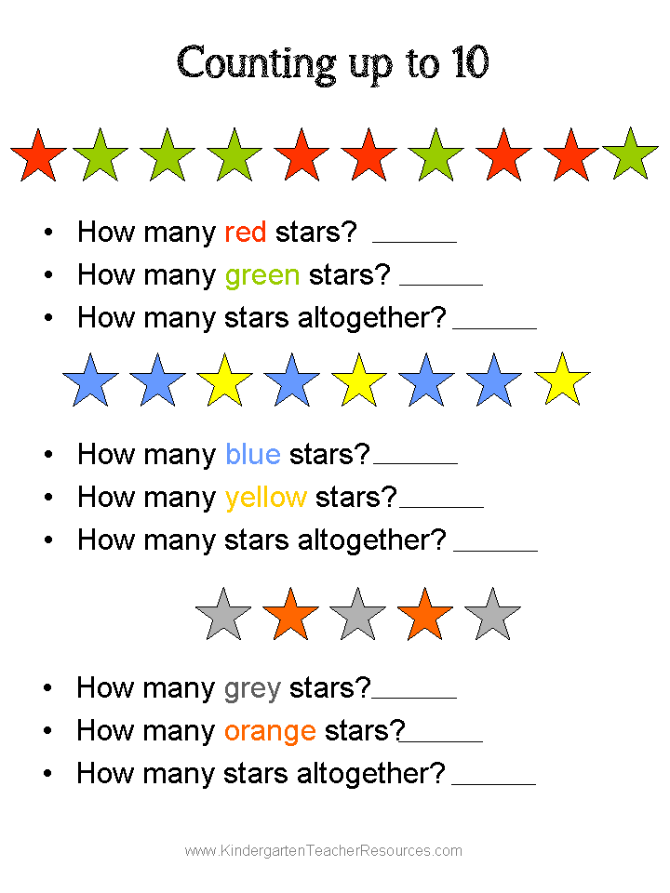  This Photo by Unknown Author is licensed under CC BY-SA
Understanding the World | Children will learn about distinct types of animals, building on their knowledge of domestic animals. Children will learn the names of offspring as well as habitats and what animals need to survive.  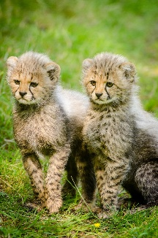 | Read stories about jungle animals and learn their names.  Explore the seasonal change and the weather. Discuss what the children need to wear for the weather and season.  Learn about David Attenborough and watch some clips from his nature documentaries.  

