KSM
500BCE
NOW
1939-1945
1914-1918
1837
1780
1066
1485
1066
790CE
410CE
43CE
800BCE
2300BCE
Anglo-Saxons
And Scots
Ancient Greeks

Modern Britain
World War I
World War II
Victorians
Industrial Revolution
Tudors
Great
Fire of
London
Stone Age
Normans
Anglo-Saxons and Vikings
Romans
Iron Age
Bronze Age
Anglo-Saxons and Vikings
Invaders and Settlers
Year groups 3&4
History

Invasion
Settlement
Trade
Democracy
Monarchy
Conflict

When – Timeline of Key Events |  | 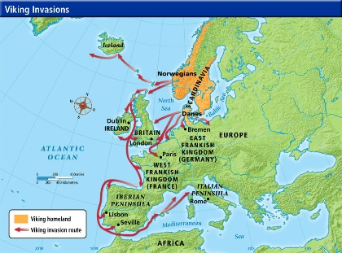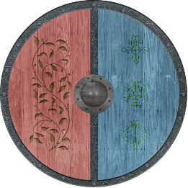  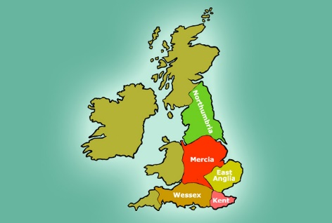  Law and Justice  King Alfred the Great made a treaty with invaders saying that the lives of both the Anglo-Saxon and Scandinavians will be treated as equal. | Key Vocabulary and Phrases
793 | Raids of monasteries, including Lindisfarne Priory. |  | Invade | To attack, to enter with the intention to take over.
796 | After the death of King Offa, Mercia and Wessex Kingdoms battled for control over England. |  | Defeat | To beat an enemy.
865 | Great Viking army from Denmark invaded England. |  | Conquer | To beat an enemy and control them using force.
866 | Danes captured York (which the Vikings called Jorvik) and made it their kingdom. |  | Monastery | A building where monks live, work and pray.
876 | Vikings from Denmark, Norway and Sweden settled permanently in England. |  | Danelaw | The Eastern area of England ruled by the Vikings.
886 | King Alfred ‘the great’ defeated the Vikings but allowed them to settle in Eastern England. The land the Vikings controlled was named Danelaw, because the rules of these lands came from the Danish (Danes) and Norse overlords. |  | Jorvik | The Viking name for York (in North East England).
927 | The kimgdoms of England were united by King Aethelstan (1st King of England) – Wessex ruled the other kingstons. |  | Expel | To force (someone) to leave a place.
954 | Eric Bloodaxe, Viking ruler of Northumbria, was expelled from Jorvik. Whole of England under Anglo-Saxon control. |  | Flee/fled | To run away from danger.
991 | King Aethelred (the unready) paid the first Danegeld ransom to stop Danish (Viking) attacks on England. |  | The confessor | The short form of Confessor of the Faith a title given by the Christian Church to a type of saint.
1013 | The Danes conquered England – Aethelred fled to Normandy. |  | Beowulf | Geatish hero of an epic poem, which tells of how he defeated the monster Grendel.
1016 | Dane, King Cnut – became King of England. |  | Taefl | Popular battle board game played by the Anglo-Saxons, Viking and Celts.
1042 | Saxon, Edward the Confessor became king. |  | Shield-wall | Defensive formation used in battle, where warriors’ shields overlap for protection.
1066 | Edward the Confessor died, Battle of Stamford Bridge, Battle of Hastings. |  | Hastings | Location of a battle where the invading Normans defeated King Harold Godwinson.
 |  |  | Bayeux Tapestry | Embroidery showing the story of the Norman Conquest, and defeat of the Anglo-Saxons by William the Conqueror.

