Robin’s Rotten Romans Homework Grid
Spring 2023
Homework in Years 3 and 4 will consist of weekly spellings, as well as reading at home and learning multiplication tables, both of which are ongoing activities. The Romans grid below contains extra activities, which can be completed anytime throughout the spring term.
Times Tables with Roman Numerals Choose a times table and write it out using Roman Numerals.  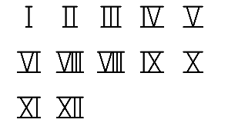 | Toga Tangle The Romans wore togas. See if you can make a toga and take a photo of you wearing it! Write some instructions for how you made the toga.   | Roman Tools Research Roman tools and make a model of one.  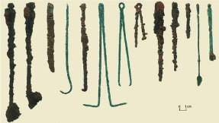 | Roman Chariot Draw and describe a Roman chariot. What were the chariots used for? Who used them?  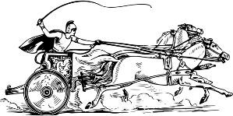
Roman Gods and Goddesses Draw a picture of a Roman God or Goddess. Add information to the picture. What were they Gods of? Did they have special powers?  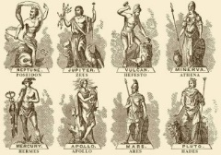 | Marching Song Write the words for a marching song that the Romans could sing while they marched.  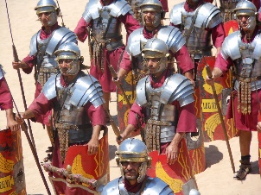 | Roman Buildings Find out about a Roman building, then make a model of it.  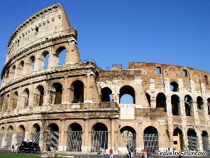 | Roman Maths Make up some Roman calculations using Roman Numerals.  VII + C = XX - V =
Interview with a Roman Soldier Write a list of 10 questions you would like to ask a Roman soldier who has come to Britain.  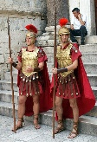 | Gladiators Learn at least 5 facts about a Gladiator. Make a fact file about what their life was like.  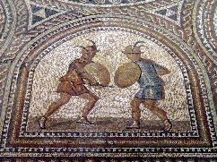 | Roman Baking Make some Roman Honey Cakes or any other Roman food. Write the recipe/take a photo/bring the food into school.  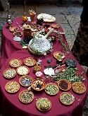 | Roman Mosaics Make your own Roman mosaic using cut paper, pasta shapes, seeds etc. Keep the design simple.  