Trips to Clent to hunt for different rock types. (Small groups by minibus)

Make your own rock. (Crayon rocks) How to erode rocks experiment.

•

•

•

**Possible Experiences**

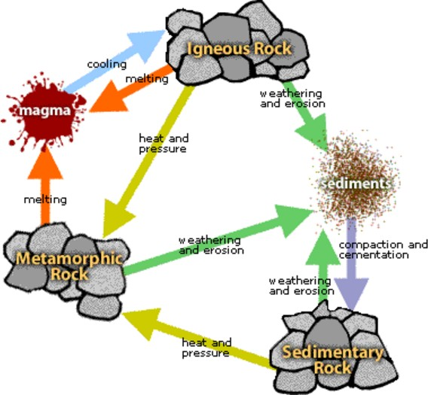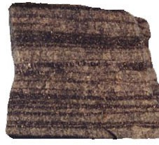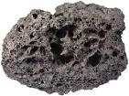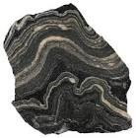

**Diagrams and Symbols**

The Rock Cycle

|  |  |
| --- | --- |
| **What?** (Key Knowledge) | |
| Types of Rocks | |
| There are three main types of rock | * Sedimentary * Metamorphic * Igneous |
| Sedimentary | **Sedimentary rocks** are formed from particles of sand, shells, pebbles, and  other fragments of material. Together, all these particles are called sediment.  Gradually, the sediment accumulates into layers and over a long period of time hardens into rock. |
| Metamorphic | **Metamorphic rocks** are formed under the surface of the earth from the  metamorphosis (change) that occurs due to intense heat and pressure (squeezing). |
| Igneous | **Igneous rock** is formed when magma  cools and solidifies, it may do this above or below the Earth's surface. |
| How to spot each type of rock | |
| Sedimentary | * Usually crumbly and allow water through them * Made of layers and stuck together with mineral crystals * They can contain fossils within their layers |
| Metamorphic | * Usually hard * May contain tiny crystals or fossils |
| Igneous | * Very hard * Contain crystals |
| How fossils are formed | |
| How are fossils formed? | * An animal dies, its skeleton settles on the sea floor and is buried by sediment. * The sediment surrounding the   skeleton thickens and begins to turn to stone.   * The skeleton dissolves and a mould is formed. * Minerals crystallise inside the mould and a cast is formed. * The fossil is exposed on the Earth's surface. |
| How is soil made | |
| What is soil made from? | * Minerals (small stone fragments: clay, silt or sand) * Organic Matter (decaying plants and animals) * Water (which the nutrients in the minerals and the organic matter dissolve into) * Air (which fills the gaps between the mineral and organic matter parts). |
| Types of soil | **Sandy soil** is pale in colour with lots of small air gaps. Water drains through sandy soil easily so it usually feels quite dry.  **Clay soil** is an orange or blue-ish sticky soil with very few air gaps. Water does not drain through it easily. When it rains, puddles stay on top of clay soil for a long time.  **Chalky soil** is a light brown soil. Water drains through it quickly.  **Peat** is different from other soils because it does not contain any rock particles. It is made from very old decayed plants and is dark, crumbly and rich in nutrients (chemicals plants need to grow). |

|  |  |
| --- | --- |
| **What?** (Key Vocabulary) | |
| **Spelling** | **Definition/Sentence** |
| Erosion | The gradual wearing away of something. |
| Magma | Hot fluid below or within the earth's crust from which lava and other igneous rock is formed on cooling. |
| Tectonic plates | A layer under the ground made up of large, moving pieces called plates. All of Earth’s land and water sit on these plates. |
| Solidify | To become solid or hard. |
| Dissolve | To become part of a liquid |

|  |  |  |
| --- | --- | --- |
| Sedimentary | Metamorphic | Igneous |



KSM - Knowledge Organiser

|  |  |  |  |  |  |
| --- | --- | --- | --- | --- | --- |
| **Science Focus:** | Rocks |  | **Year 3/4** |  | **YEAR B**  **AUTUMN** |

|  |  |  |  |  |  |
| --- | --- | --- | --- | --- | --- |
| KSM - Knowledge Organiser | | | | | |
|  | | | | | |
| **Science Focus:** | States of Matter |  | **Year 3/4** |  | **YEAR A**  **AUTUMN 2** |

|  |  |  |  |  |  |  |
| --- | --- | --- | --- | --- | --- | --- |
| **What?** (Key Knowledge) | | | | | | |
| Grouping Materials | | | | | | |
| Materials fall into four main categories | | | * Solids * Liquids * Gases * Plasma (Not part of our curriculum) | | | |
| How to spot each type of material | | | | | | |
| Solids | | | * Solids stay in one place and can be held. * Most solids keep their shape. They do not flow like liquids. (Some solids like sand or salt can be poured) * Solids always take up the same amount of space. They do not spread out like gases. | | | |
| Liquids | | | * Liquids can **flow** or be **poured** easily. They are not easy to hold. * Liquids change their shape depending on the container they are in. | | | |
| Gases | | | * Gases are often invisible. * Gases do not keep their shape. They spread out and change their shape and volume to fill up whatever container   they are in. | | | |
| Changes of state | | | | | | |
| What does changes of state mean? | | | * What a material changes from one material type to another, we say ‘it has changed state.’ | | | |
| What are the changes of state? | | | | | | |
|  | What | Explanation | | Name of process | Example |  |
|  | Solid to Liquid | When a solid **melts** it changes to a liquid. | | Melting | When an ice cube melts. |  |
|  | Liquid to Gas | A liquid  **evaporates** into a gas when it is heated. | | Evaporation | When water on a roof is warmed up and turns to steam. |  |
|  | Gas to Liquid | When a gas it cooled it  **condenses** into a liquid. | | Condensation | When steam from the shower  cools on the mirror it turns to  water. |  |
|  | Liquid to Solid | When a liquid **freezes** it turns into a solid. | | Freezing | When the water in a pond  freezes, it turns to ice. |  |
|  | | | | | | |
| At what temperature does each happen? | | | | | | |
| Boiling | | | * Water boils at exactly 100°C (A hot bath is about 40°C) | | | |
| Melting | | | Different solids melt at different temperatures:   * Ice melts at 0 degrees Celcius (0°C). * (Chocolate melts at about 35°C) | | | |
| Freezing | | | Water freezes at 0 degrees Celcius (0°C). | | | |
| Evaporation and Condensation | | | * Water can evaporate and condense at any temperature. But, the warmer it is the faster the evaporation takes place. | | | |

|  |  |
| --- | --- |
| **What?** (Key Vocabulary) | |
| **Spelling** | **Definition/Sentence** |
| Temperature | The measure of warmth or coldness of an object. |
| Celsius | The common scale in the UK for measuring temperature. |
| Boils | To become so hot (100°C) that water bubbles and then turns into a gas. |
| Container | Something which holds things inside, like a box, jar or tub. |

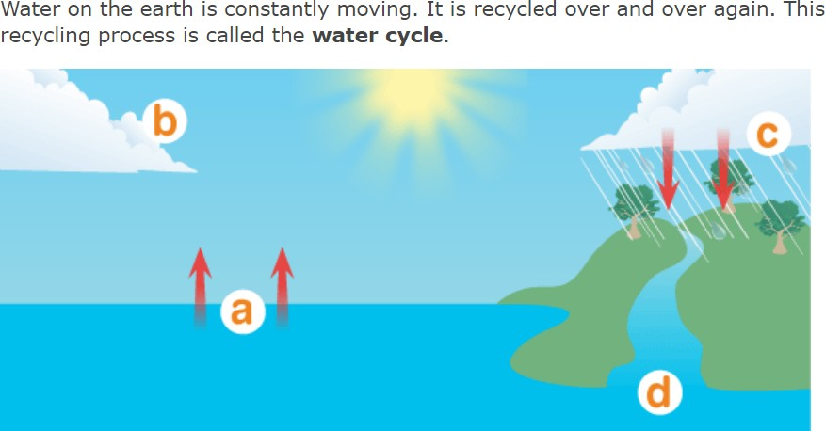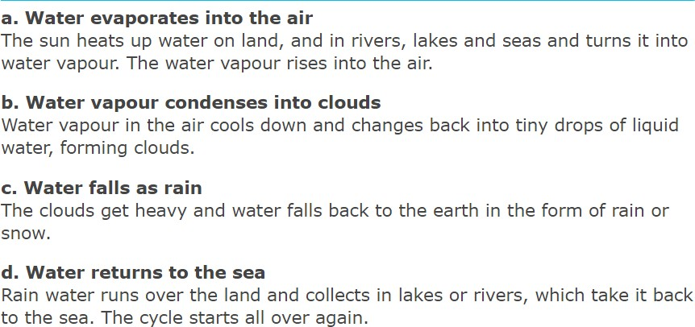

**Diagrams and Symbols**

The Water Cycle

|  |
| --- |
| **Possible Experiences** |
| * Experiment with varying melting points of foodstuffs. (Do healthy foods melt quicker/ slower?) * How can we get washing to dry faster? * Create a solar water still. |

Copyright © - J. Harrold and I. Lloyd 2017