30 July 2026

Dear Parents,
Rotten Romans
During this topic, the children will learn about the key events during the Roman invasion of Britain, adding to their chronological understanding. They will learn about what life was like in Britain at this time, both for the invaders and the British who already inhabited our country. They will use the knowledge they have gained about Roman Britain to write stories, diaries, reports and newspapers. They will create Roman inspired artwork and products. The children will also meet a Roman centurion and hopefully bring the facts they have been learning in the classroom to life.
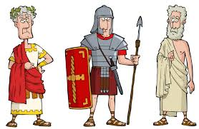

English | STORIES WITH HISTORICAL SETTINGS Based on ‘Escape from Pompeii’; read, analyse and map the stages of stories with a historical setting in preparation to plan, write and edit own story with a Roman setting.  DIARY Using facts about life in Pompeii; write diary entries of different fictional or real characters from the past.  NON-CHRONOLOGICAL REPORT Read a range of non-chronological reports; recognise the structure and language features; use information collected about life in Roman Britain from reading more than one source; plan, write, edit and publish reports about an aspect of the topic studied.  NEWSPAPERS Read real and fictional newspapers; organise and sequence a recount, identifying key events; read and discuss concepts of 'fact' and 'opinion'; plan, write, edit and publish newspapers about key events during the Roman occupation of Britain.  MAGAZINES Using an understanding of the difference between fact and opinion; produce a class magazine.  READING Reading is taught in different ways, using a rich variety of texts. During writing sessions, pupils investigate a text in depth, usually linked to topic work. In guided reading sessions, children work in smaller groups, on a range of texts. These sessions are targeted to develop their reading (decoding) and comprehension skills at their individual level. As well as taking books home, a love of reading is encouraged through reading corners, author studies and celebrations of reading and literature.
Maths | We will be following White Rose Planning for Year 3&4. We will also be using Purple Mash and having a Times Table Olympics in class. We will focus on:  - Multiplication and Division.  - Decimals.  - Properties of Shape.  - Fractions.  - Length and Perimeter.
History | ROTTEN ROMANS Know and understand AD and BC; when and why the Romans invaded Britain; British resistance; life in Roman Britain and the Roman number system. Place key Roman events on a timeline and be able to describe them; ask and answer questions about Roman life; understand the causes and consequences of change; use different sources and understand why they can be interpreted in different ways; construct informed responses and represent in different ways. Use virtual tours to see the remains of a Roman settlement, Roman mosaics and other finds, handle Roman artefacts and experience to flavours and textures of Roman food.
Geography | VILLAGES AND CITIES Using examples of Roman settlements as a basis, know the features of and differences between cities and villages; explain why people choose to live in both; use maps and atlases, both physical and digital to locate specific places; know the symbols they use for different physical features; examine how land was used then and now.
Science | FORCES AND MAGNETS  The children will be exploring different forces and their affect on things in our world. In addition to this we are looking at how magnets work and can be used through a range of experiments.  LIGHT AND SOUND  Towards the end of this term we are diving into the wonders of light and sound through our own or others scientific discoveries throughout time.
Personal, social and health education | WELL-BEING AND MENTAL HEALTH  This term we shall be focusing on our mental health and what we can do to help deal with these different emotions using calm spaces and talking to trusted people. It is okay to talk about our emotions.

Design Technology | ROMAN SANDALS, TREASURE BOXES AND SHIELDS (Textiles & Mouldable Materials) Consider the preferences of the user; consider how to suitability of the materials; use a template; explain how to join; use a range of techniques; use finishing techniques.
Religious Education | CHRISTIANITY –This term we shall be exploring Christianity and their views and beliefs towards salvation.
Art and Design | ROMAN MOSAICS Examine Roman mosaics; select ideas to use in our designs; understand the materials used in mosaics; design and create our own mosaics; evaluate these and suggest improvements. Begin to show facial expressions and body language in their sketches; create mood in my paintings; organise line, tone, shape and colour to represent figures and forms in movement; begin to sculpt clay and other mouldable materials.
ICT | Mrs Willis will be planning this part of the curriculum. Although, the children will be using the class IPADS for research and topic based activities in class.
Music | Mrs Miller will be planning this part of the curriculum exploring a range of different types of music.
French | Mrs Colombet will be planning this part of the curriculum trying French foods and learning how to count.
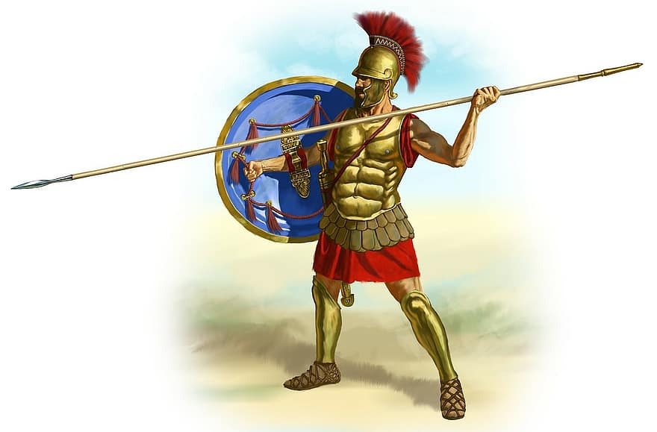
In terms of home learning, your child will continue to be set homework but in a variety of formats. I have included a topic based ‘Homework Grid’ with this letter. The children can choose a minimum of three activities from this grid to complete over the Spring Term. The children will still have spellings each week. It is imperative for their learning to look up the definition of each spelling and learn the spelling pattern.

Please could the children bring in a piece of fruit or vegetable for their healthy snack at break time and a bottle of water.

Please do get in touch if you have any concerns or questions over the next few months.

Yours sincerely,

Charlie Mallender
Class Teacher

