|  |  |  |  |
| --- | --- | --- | --- |
| What will you choose to do? | | | |
| Plant bulbs and seeds at home and watch them grow. Bring in your plants (or  photographs of them) to show your class. Can you write a diary explaining how you grew your plant? | Grow a sunflower and keep a record of its height in a table. Who can grow the tallest in the class? Challenge a friend. | With an adult, search the web for examples of amazing plants and make your own weird and wonderful plant book. | On a visit to the supermarket, find and discuss plants you can eat, including herbs, vegetables and fruit. Which part of the plant are they? The roots? The leaves? The flower? The stem? |
| Learn how to spell the names of some common flowering plants such as rose, daisy, iris and tulip. | Visit the local library and find nonfiction books about planting. Look for information using the contents and index pages. Write down any new facts you have learned and bring them in to share with the class. | Grow a herb garden at home and use your herbs in some delicious recipes for your family and friends.  You could share your recipes with the class. | Visit a garden centre, florist or plant sale, or take a walk in your garden or local area. Amaze your adults with your knowledge of plant names. Find out the names of any plants you don’t recognise. |
| Observe someone cooking. List the herbs used in the recipe. |
| Paint or draw flowers growing in the local environment or in a vase or pot in your home. Find pictures online of famous flower paintings and talk about your likes and dislikes with your adult. | Press flowers between the pages of a book and use them to make gifts or cards for your family and friends. | Make model flowers. Explore colour and pattern by mixing and layering tissue paper and cutting and tearing spots and stripes for patterns. You could use recycling materials! | Read and talk about stories and poems with your adult on the theme of flowers and plants. |

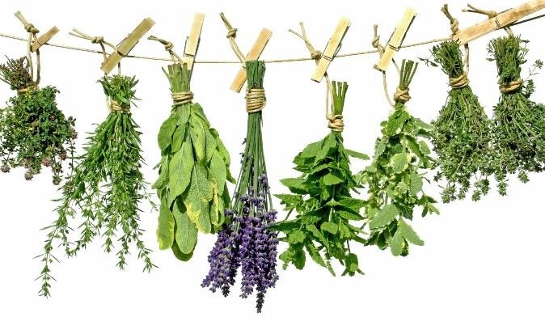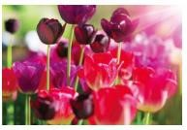 Plants Home Learning grid