Robin’s River Deep, Mountain High Homework Grid
Summer 2023
Homework in Years 3 and 4 will consist of weekly spellings, as well as reading at home and learning multiplication and division facts, both of which are ongoing activities. The grid below contains extra activities, which can be completed anytime throughout the summer term, at least 3 need to be completed.
UK Mountains  Research the mountains in the UK. List them and find out where they are on a map of the UK. | World Mountains  Find out about the world’s tallest mountains. Which continent and countries are they in? | Mountain Medical Matters  Find out about one of the medical problems climbers may encounter and how to avoid or cure them: Hypothermia; Altitude or Mountain Sickness; Dehydration and Frostbite. | River fact file  Compare some World or UK Rivers. Your findings can be presented in any way you wish; use a model, a painting, an information booklet or even a PowerPoint.
Survival bag  Decide what you would include in your survival bag for a trek up the Himalayan Mountain Range. You may take 10 items for you to carry personally. Explain why they will help you to survive. | 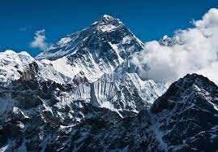 | 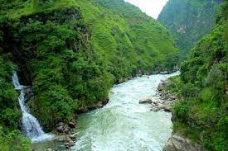 | Story Time  Write a story that’s based in a mountain range, a story that’s about explorers or people who live in that environment. You could include animals or the mythical yeti!
MasterChef  Create a meal that would provide the essential energy required for a mountain hike. | Landscape picture  Use paints, crayons, pencils or felt tips to draw a landscape picture including mountains and / or a river. | Diary entry  Write a diary entry as if you were a mountain explorer. What amazing things would you see and discover. | Mountain Design  Make your very own mountain in whichever form you wish.

