Robins Homework Grid Autumn Term 2022

Homework in Years 3 and 4 will consist of spellings, as well as reading at home and learning multiplication tables, both of which are ongoing activities. The Stone Age grid below contains extra activities, which can be completed anytime throughout the Autumn Term. Your child will have the opportunity to present their hard work to the whole class once brought in.
Cave Art  Make up your own story. It can be about anything you like, but tell it through stories (pictures/cave drawings).  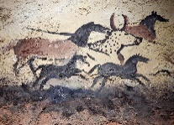 | Time Travellers  Imagine you have been whisked back in time to Pre-historic Britain. You have been allowed to take one object and one person from 2022. Who/What would you take and why? Explain reasons for your choice.   | Cave Homes  During the Stone Age, people lived in caves. If you had to live in a cave, what would it look like and who would live with you? Be as creative and imaginative as you like. Maybe even build your own 3D cave.  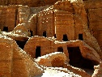
Stone Age Recipe  Stone Age people could not pop to the shops to buy their food. Everything they ate had to be caught or collected. Write your own recipe for a stone age dinner using the sort of ingredients that would be available to them.  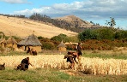 | A typical day in the Stone Age  Create a comic strip to show a typical day in the Stone Age. Think what a cave dweller might do —hunting, making weapons/tools.  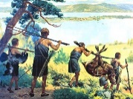 | Tools  What tools were used in the Stone Age, Bronze Age and Iron Ages? Research and make your own tools like those that were used in Prehistoric Britain.  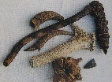
Clothing  Invent an outfit for a cave dweller. Think about the materials that were available to them at the time.  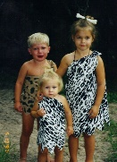 | Prehistoric Animals  Which animals can be seen in the Stone Age? Research them and create fact file/poster/drawings of each. How many can you find?  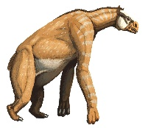 | ‘How to survive the Stone Age’  Create a leaflet for ‘How to survive the Stone Age.’ Imagine you are transported back to the Stone Age and need a guide to help you survive. What would the guide say? What tips would it have? Use ICT, if you can.

