Kingston St Mary Primary School
EYFS Curriculum Newsletter
September 2024
Curriculum Information - Topics
Autumn 1 | Autumn 2 | Spring 1 | Spring 2 | Summer 1 | Summer 2
Marvellous Me | Let’s Celebrate | People Who Help Us | New Life | Amazing Animals | It’s a Wonderful World

Reception Curriculum
Curriculum Area | EYFS | Home Enrichment Activities
Personal, Social and Emotional Development | Children will have the opportunity to share their thoughts and feelings in circle time. Pupils will be encouraged to talk about their likes and dislikes and begin to identify similarities and differences between themselves and others. Children will consolidate their understanding of the EYFS rules and routines. We use the visuals below to help understand Reception behaviour expectations.  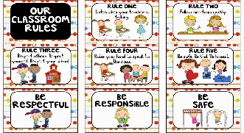  This Photo by Unknown Author is licensed under CC BY-SA | Reinforce expected behaviour in the home setting. Discuss the consequences of inappropriate behaviour/actions.  Talk about feelings with your child and help them to understand happy, sad, angry and scared. Encourage them to express how they are feeling.  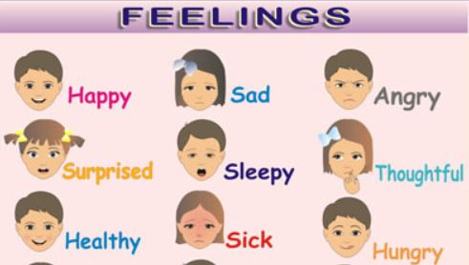
Physical Development | Children will access the outdoors and develop balance and coordination skills to enable them to travel in a variety of ways, including over, under, through and around obstacle equipment. Pupils will explore outdoor equipment such as bikes, scooters, skipping ropes, steppers, bats and balls. This will develop children’s gross motor skills.  Children will engage in a variety of fine motor control activities including threading, construction, mark-making and dough activities. Pupils will also access targeted Dough Gym and Squiggle and Wiggle activities to support pencil grip and strength. This half term we will be focusing on scissor skills. We will also practise peeling and cutting soft fruit and vegetables.  Pupils will practise health and self-care routines including: hand washing, blowing their nose and dressing for the outside environment. | Encourage your child to be fully proficient when using the toilet and washing their hands.  Support pupils to develop the ability to cope with dressing and undressing.  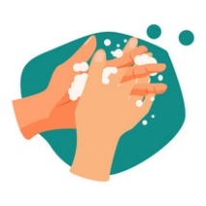  Create a fruit salad or soup with your child. Encourage them to peel, cut and slice with support.
Expressive Arts and Design | Children will explore drawing techniques and will begin to use different line types of materials to produce artwork (paint, college, clay, playdough and pastel).  During child-initiated learning, pupils will have access to a wide variety of creative materials and will be able to express their own creativity. Pupils will be able to access a variety of small world and role play activities to develop their expressive language.  Pupils will develop their repertoire of nursery rhymes, action songs and themed songs. They will use Charanga to develop an understanding of rhythm and beat within music. | Encourage your child to sing songs from school in their home setting.  Allow your child to access a wide range of creative activities: painting, collage, creative role play etc. Why not make a family portrait? We would love to see these.
Communication and Language  Literacy | Children will be encouraged to take part in circle time activities within small groups and whole class. There will be lots of opportunities for pupils to express their views, share stories and become confident to speak in a familiar group.  Pupils will have the opportunity to engage in role-play to develop their expressive language.  Speech and Language intervention will be delivered to target pupils to develop their expressive and receptive language and early years development.  The key texts this half term will be Hansel and Gretel and The flying Bath. Children will continue to recall story events and will have the opportunity to re-enact stories in their play. Pupils will explore the following stories in class.  - Harry and His Bucketful of Dinosaurs – Starting School.  - Funny Bones.  - Titch.  - Starting School.  - You Choose.  - All Kinds of People.  Songs covered will include:  - One, Two Buckle My Shoe.  - Little Bo Peep.  - Head, Shoulders, Knees and Toes.  - Jack and Jill.  - Little Miss Muffet.  - Dingle Dangle Scarecrow.  Children will access RWI, a phonics programme introducing the children to phonemes and graphemes.  Pupils will develop their writing skills. Working on letter formation, their names and words/sentences containing the learned phonic sounds.  The children will also begin to read some high frequency words. | Encourage your child to speak to a range of adults in the home setting. Encourage your child to ask and answer two-part questions and instructions.  Encourage your child to identify letters in the environment.  Access Read Write Inc online to find out more about the phonics programme. You can also access resources to support the programme.  Read a story to your child every night. Encourage your child to talk about the illustrations in the stories. Model how to hold a book correctly and turn pages. Feed your child’s imagination and deepen their vocabulary by telling them a range of stories.  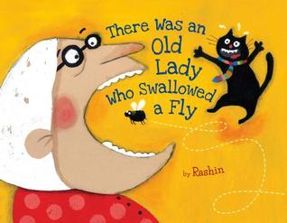
Mathematics | Pupils will be introduced to Numicon, which is a multi-sensory resource to support mathematical concepts, for example patter, addition and problem solving.  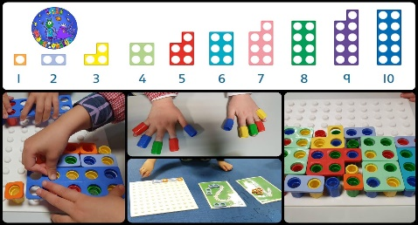  Children will consolidate their understanding of the numbers 0-5; counting up to five objects accurately and matching to the correct numeral.  Pupils will also develop their understanding of ‘one more’, find the total number of items in two groups by counting and begin to use the vocabulary involved in addition. | Practise counting with your child. You might like to count objects in the home setting. Encourage your child to place objects in line whilst counting and to touch count.  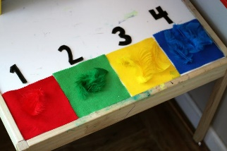  Go onto the Numicon website. Mention numbers in the environment for example, on registration plates, buses, doors and encourage them to recognise and name the numerals they see.  Have a look at Numicon games at home that are available for iPad.
Understanding the World | Children will talk about the place that they live and the other places they know in the area. They will be introduced to a World Map and find and name their home country. We will discuss families, friends and what we enjoy as we get to know each other’s.  They will draw and label the human body. They will explore the five senses and say which body part is used for each sense.  This half term we will be learning about Harvest, Sukkot and the build up to bonfire night. We will be noting the changes in seasons and what they can see is changing around them.  Children will find out about objects at home and school that use electricity. We will explore light and how it travels through transparent materials. We will also explore stretchy and non-stretchy materials. | Look at photographs, talk about their family and what they are doing in the photo. We would love to see some of the photos in school too.  Encourage your child to observe and describe the signs of Autumn. Collect fallen leaves and allow your child to produce leaf pictures. Your child may like to bring fallen Autumnal leaves to school.    Find and name objects at home that use electricity and talk about how they are used.

