Kingston St Mary Primary School
EYFS Curriculum Newsletter
November 2024
Curriculum Information - Topics
Autumn 1 | Autumn 2 | Spring 1 | Spring 2 | Summer 1 | Summer 2
Marvellous Me | Let’s Celebrate | People Who Help Us | New Life | Amazing Animals | It’s a Wonderful World

Reception Curriculum
Curriculum Area | EYFS | Home Enrichment Activities
Personal, Social and Emotional Development | Children will consolidate their understanding of their own feelings and the feelings of others. Pupils will engage in circle time activities discussing the importance of kind hands, kind feet and kind words. This half term, children will be learning about the Christmas story and sing festive songs. They will develop their listening skills and turn taking.    Children will continue to develop selfcare skills, including putting on and fastening their own coat. Fastening buttons and putting on/taking off their school jumpers. | Continue to reinforce expected behaviour in the home setting. Praise positive choices and discuss the consequences of inappropriate behaviour and actions. Play games together that involve turn taking and model how to wait patiently. Encourage your child to talk about upcoming events and celebrations. Pay attention to the way they communicate, prompting them to speak in full sentences. Encourage your child to get dressed and undressed independently, practising those things that they find tricky. Get your child to practise putting on their own coat and doing up the zip.
Physical Development | Children will continue to use the outdoor classroom and access the Trim Trail. Here, they will work on developing their strength, balance and coordination. PE will be included in outdoor activities as well as accessing the hall for sessions. Children will engage in a range of ring games and parachute games, developing team building skills and cooperation. We will also be learning Christmas party games and dance. We will be working on developing fine motor skills in the classroom to support children’s writing. Activities such as playdough, threading and cutting will be available daily. | Access YouTube and practise party songs (Superman, Cha cha slide, Hokey Cokey). Take your child on a walk to practise their gross motor skills (stomping, skipping, running or walking). Encourage your child to get dressed and undressed independently, practising those things that they find tricky. Get your child to practise putting on their own coat and doing up the zip. Encourage your child to practise the letters we have looked at so far (m a s d t I n p g o c k u b f e l h sh r j v y w x ng nk) using a mark making tool. This could be chalks, pens and pencils or their fingers.
Expressive Arts and Design | Children will explore painting this half term. They will learn painting techniques and use different tools to produce art work. They will explore mixing colours and learn about primary colours. Children will be learning to add details to pictures, such as eye lashes and eye brows to a face and patterns to an animal’s fur. They will be moulding clay for sculptures (Diwa lamps) and using junk modelling equipment to make nativity scenes. During child initiated learning pupils will have access to a wide variety of creative materials and will be able to express their own creativity. Pupils will be able to access a variety of small world and role play activities to develop expressive language. While preparing for our Christmas performance children will learn new songs and dances. They will also have the opportunity to act out a story. | Create firework pictures using black paper and splash paint. Create a card for a family member’s birthday, Can they write a birthday message inside the card? Encourage your child to practise the songs for the Christmas performance. If you child has lines to learn get them to practise these with a loud voice. (these will be sent home via Marvellous Me)
Communication and Language | Children will continue to take part in circle time activities within small groups and whole class. There will be lots of opportunities for pupils to express their views, share stories and become confident to speak in a familiar group. Pupils will have the opportunity to engage in role play to develop their expressive language. Language intervention will be delivered to target pupils, developing their expressive and receptive language and early language development. Your child’s teacher will have communicated this with you if it concerns your child. | Encourage your child to speak to a range of adults in the home setting. Encourage your child to ask and answer two part questions and instructions.  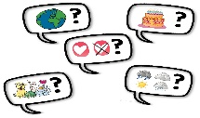  This Photo by Unknown Author is licensed under CC BY-SA-NC  Go the toilet then wash your hands.
Literacy | Children will continue to recall story events and will have the opportunity to re-enact stories in their play. Pupils will explore the following stories in class:  • Binny’s Diwali  • The tortoise and the Hare  • Little Glow  • cake  • The Dinosaur that Pooped Christmas • The Jolly Christmas Postman  • Stickman  • The Christmas Story/Nativity Songs covered will include:  • I Hear Thunder  • Rain Rain Go Away  • One Finger, One Thumb  • Little Jack Horner  • Here We Go Round the Mulberry Bush  • Christmas Songs and Rhymes Children will access Read Write Inc, a phonics programme continuing to introduce the children to phonemes (sounds) and graphemes (letters). Children will take part in reading sessions. They will continue to bring the book home that they have practised reading in school. Pupils will develop their writing skills, practising their names and words/sentences containing the learned phonics sounds. Write small captions and sentences dictated by a teacher e.g. The man sat. Children will be beginning to use capital letters accurately as well as finger spaces and beginning to use a full stop to punctuate. Children will also be adding further tricky words to their reading and writing. | Listen to your child read their reading book, developing confidence and fluency in their reading. Record the tricky words on paper and display them around your house. Can your child find and read all of the words? Encourage your child to identify letters in the environment, e.g. number plates, signs, magazines etc. Encourage your child to read any words they can blend if they see when out and about eg. in the supermarket. Read a story to your child every day. Encourage your child to talk about the illustrations in the stories. Model how to hold a book correctly and turn pages. Feed your child’s imagination and deepen their vocabulary by telling them a range of stories. Encourage your child to mark make at any opportunity (bath chalks, water and paint brushes, shaving foam). Ensure practise writing their first name and surname if they can extend this to words they can read, can they record them too? Can they write about a picture they have drawn?  
Mathematics | Children will continue to work on their numerals and matching pictures to represent those numerals. They will continue to develop their skills of subitising (the ability to look at the objects and instantly recognise the amount without counting). They will consolidate finding one more or one less, whilst establishing compositions of Numbers to 10. The children will revisit pattern, and number bonds to 5 and extend this to 10. We will be exploring 3 and 4 sided shapes and the properties of these shapes.  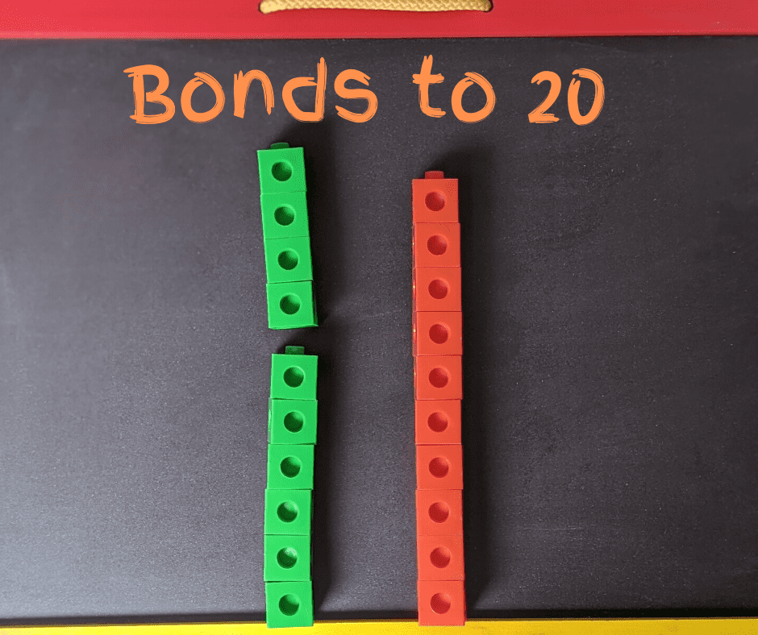 | Talk to your child about what they see around the house, encourage them to tell you the shapes of what they see and how many. Encourage your child to talk about one more of those items or one less. They could also practise the formation of the numerals using objects from around the house or on paper. Take your child on a walk and encourage them to count how many houses they see or how many leaves are on the floor. Can they tell you one more/less and can they record these numbers?
Understanding the World | This half term children will learn about different celebrations and festivals from around the world focusing on Birthdays, Christmas, Diwali, New Year, Chinese New Year, Easter, Shavuot, Hanukah. We will look at the celebrations of Bonfire Night and how we and others celebrate them. Children will talk about what and how they celebrate with their family. We will look at how Christmas is celebrated around the world and in the UK and how this is the same/different.  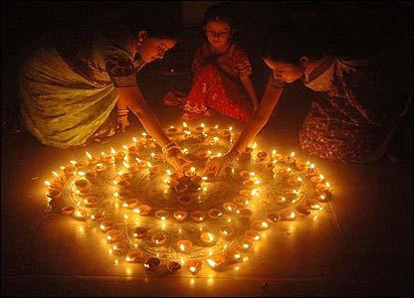 | Talk to your child about what you celebrate as a family. Allow your child to get involved with the preparation for these celebrations. Discuss your child’s birthday with them. Do they know the date of their birthday? We will be asking and recalling this in class. Do they know the year they were born? What festivals do you celebrate as a family? Can the children discuss these and what they do at this time? Could they make a picture of their favourite things about this celebration and write a little about it?

