A Day in the life of a child in Kingston EYFS 2022-2023

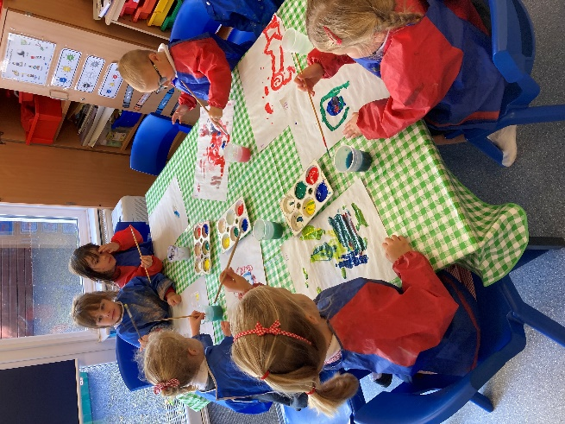 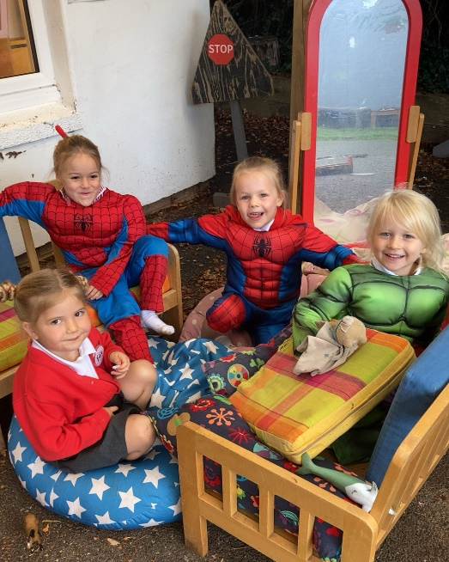

Our Typical Timetable

8.40am Children gather on their playground circle and make their way into Owls classroom. Carpet activities are available to children after they have unpacked their bags.

8.50am We gather together on the carpet for registration, a greeting song, discuss the date and run through the visual timetable.

9am Wake & Shake activity or song.

9.05 – 9.20 Literacy or Maths input. Interventions may happen during this time. Whole class or group guided opener to a concept linked to the work that follows.

9.20 – 10.05am Literacy/Maths activities along with Continuous provision. These activities can be Adult Led, Enhanced Provision or observations.

10.05am Tidy area and reset provision.

10.10am Handwashing.

10.15 – 10.30 Snack Time – listening to a piece of music.

10.30 – 10.45 Break Time.

10.50 – 11.35 Literacy/Maths activities along with continuous provision. These activities can be Adult Led, Enhanced Provision or observations.

11.35 – 11.45 Tidy areas and reset provision.

11.45 – 11.50 Story/Nursery rhymes on the carpet.

11.50 – 12 Handwashing, prayer and lining up for lunch.

12 – 1.15 Lunch

1.15 – 1.45 Collective Worship in the hall.

1.45 – 2.30 Adult directed teaching time with a particular focus in either Music, Art, PSED, PE, RE etc. along with Continuous Provision.

2.30 – 2.40 Tidy away and reset classroom.

2.40 – 3pm Story/Circle Time/Assessment of the day.

3pm – 3.10pm Pack bags and get ready to go home.

3.10pm Home Time.

